**Software Requirements**

**Specification**

**for**

**Enhanced Faculty Loading System**

**Version 1.0 approved**

**Prepared by Ochotorena, Rafael**

**Asia Pacific College**

**November 23, 2016**

**Copyright © 1999 by Karl E. Wiegers. Permission is granted to use, modify, and distribute this document. Software Requirements Specification for Faculty Loading System.**

# Table of Contents

Table of Contents 2

Revision History 2

1. Introduction 1

1.1 Purpose 1

1.2 Document Conventions 1

1.3 Intended Audience and Reading Suggestions 1

1.4 Product Scope 1

1.5 References 1

2. Overall Description 1

2.1 Product Perspective 1

2.2 Product Functions 2

2.3 User Classes and Characteristics 2

2.4 Operating Environment 2

2.5 Design and Implementation Constraints 2

2.6 User Documentation 2

2.7 Assumptions and Dependencies 2

3. External Interface Requirements 3

3.1 User Interfaces 3

3.2 Hardware Interfaces 3

3.3 Software Interfaces 3

3.4 Communications Interfaces 3

4. System Features 3

4.1 System Feature 1 4

4.2 System Feature 2 (and so on) 4

5. Other Nonfunctional Requirements 4

5.1 Performance Requirements 4

5.2 Safety Requirements 4

5.3 Security Requirements 5

5.4 Software Quality Attributes 5

5.5 Business Rules 5

6. Other Requirements 5

Appendix A: Glossary 5

Appendix B: Analysis Models 5

Appendix C: To Be Determined List 5

# Revision History

|  |  |  |  |
| --- | --- | --- | --- |
| **Name** | **Date** | **Reason For Changes** | **Version** |
| Rafael Ochotorena | 11/26/16 | Document Created | 1.0 |
| Rafael Ochotorena | 11/29/16 | Filled-up missing parts | 1.1 |
| Rafael Ochotorena | 11/30/16 | Updates for necessary changes | 1.2 |

# Introduction

## Purpose

This document is version 1.2 of SRS, it describes how the product, Enhanced Faculty Loading System aims how to improve the teaching capability of Asia Pacific College, how the product is used, who uses it and how it was developed. This document also explains the step by step interface of the product and all other requirements the product needs.

`

## Document Conventions

While reading this document, certain words or phrases might be used for specific reasons. The document conventions are the following:

Algorithm

A process or set of rules to be followed in calculation or other problem-solving operations, especially by a computer.

Power BI

It specifically shows how the loading is done and how the criteria are weighted.

Intranet

Since the Flavio System can only be accessed within the school, it is because its network is based on TCP/IP protocols belonging to an organization which is Asia Pacific College and it can only be accessed by the faculty and students within the school area.

## Intended Audience and Reading Suggestions

This document is intended for the Executive Director and the faculty members of the School of Computing and Information Technology in Asia Pacific College. The rest of the Software Requirements Specification document contains the overall description of the product such as its functions and user classes, the external requirements of the product which explains the walkthrough of the product and how the product came to be, and also all other requirements the product needs for its functionality.

## Product Scope

This product aims to quicken the process of faculty loading for the Executive Director by giving her less paper works, for the faculty to have more time preparing their lesson plans, and for the students to receive a better quality of teaching. This product will also use an analytic-based reporting system that provides a comprehensive report on faculty loading. If this product is integrated, it will truly give efficiency for the Director’s workload.

## References

<List any other documents or Web addresses to which this SRS refers. These may include user interface style guides, contracts, standards, system requirements specifications, use case documents, or a vision and scope document. Provide enough information so that the reader could access a copy of each reference, including title, author, version number, date, and source or location.>

# Overall Description

## Product Perspective

This product will replace the old manual process of faculty loading with an enhanced faculty loading system that will be efficient and effective. This product is a component of the Flavio system by which all necessary data are received from Flavio.

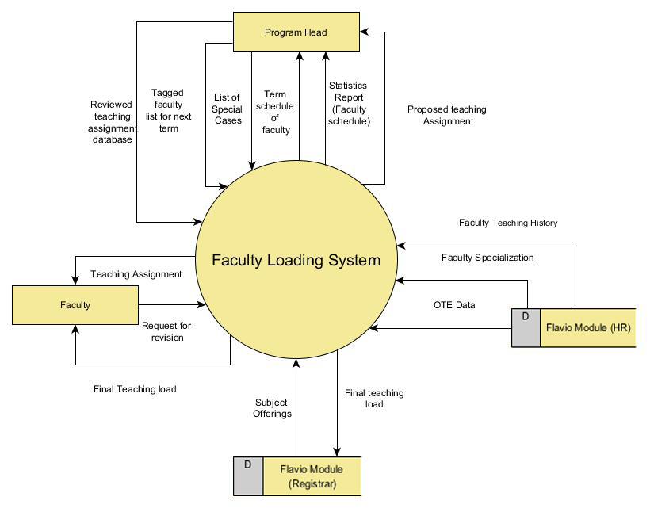

## Product Functions

The major functions the product are the following:

* Matching of faculty to their respective schedules
* Algorithm for careful considerations of factors used for matching
* Reporting system to provide a report on how the matching is done

## User Classes and Characteristics

This product is aimed the Executive Director and the faculty members but the faculty members can only view on their schedules. The Executive Director, however, will use the system for loading the faculty members’ schedule. Both the users may use the system anytime but the system will be used specifically before the start of the next term.

## Operating Environment

The software would be able to operate to any operating system but Windows 7 (or later) would be the most preferred to use. Any web browser may be used for the system since it will be integrated to the Flavio system of Asia Pacific College.

## Design and Implementation Constraints

As stated in the main document to which the criteria for loading is mentioned, some rules must be followed:

* No 3 consecutive classes for each faculty
* No more than 21 units for full-time faculty
* No more than 15 units for part-time faculty
* No more than 8 hours of work load each day for each faculty
* No more than 4 preparations for each faculty

If the system would be integrated, specific softwares are highly recommended, HTML and PHP and MySQL for the database management. The school will be responsible for maintenance once the system is deployed.

## User Documentation

Other than this document, other documentations were also delivered for this product one of which is found in projects2.apc.edu.ph/wiki under CSPROJ2 projects. Also, other documents can also be found on GitHub.

## Assumptions and Dependencies

Since the product is limited to the School of Computing and Information Technology only, future alterations and updates will expand the product’s clients. When integrated, continued maintenance will expand the product’s scope. The product will be integrated in APC’s information system, Flavio. If the information system would be updated, this product has to be maintained in order to sync with the system properly.

# External Interface Requirements

## User Interfaces

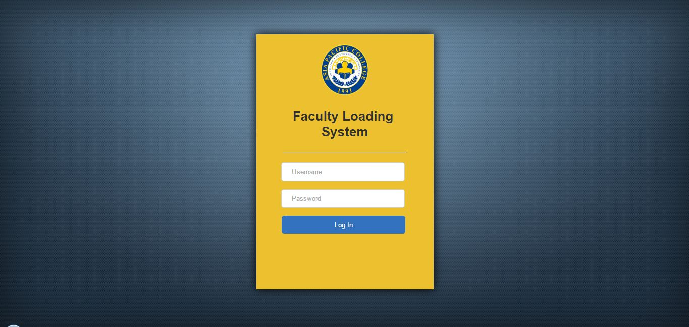In order for the software to be used, the user must first login to the Flavio System.

If the user is the Executive Director, he/she would be able have access to all software control.

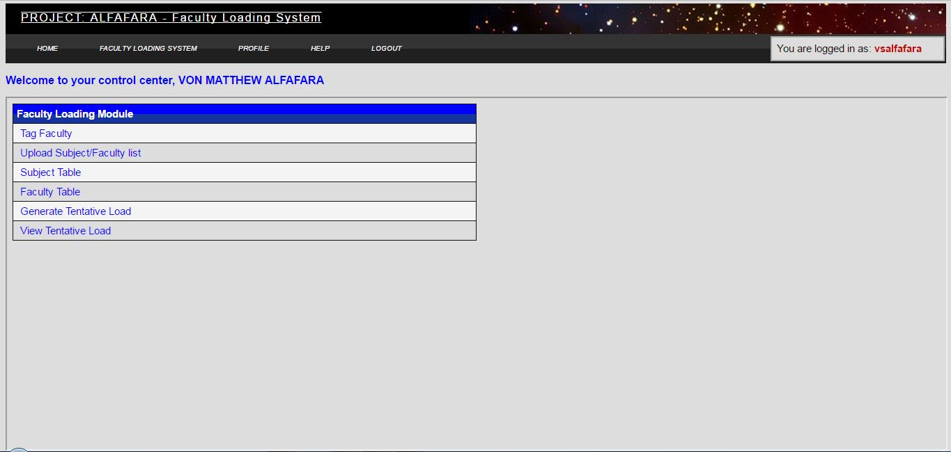

He/she would be able to view the data necessary for loading.



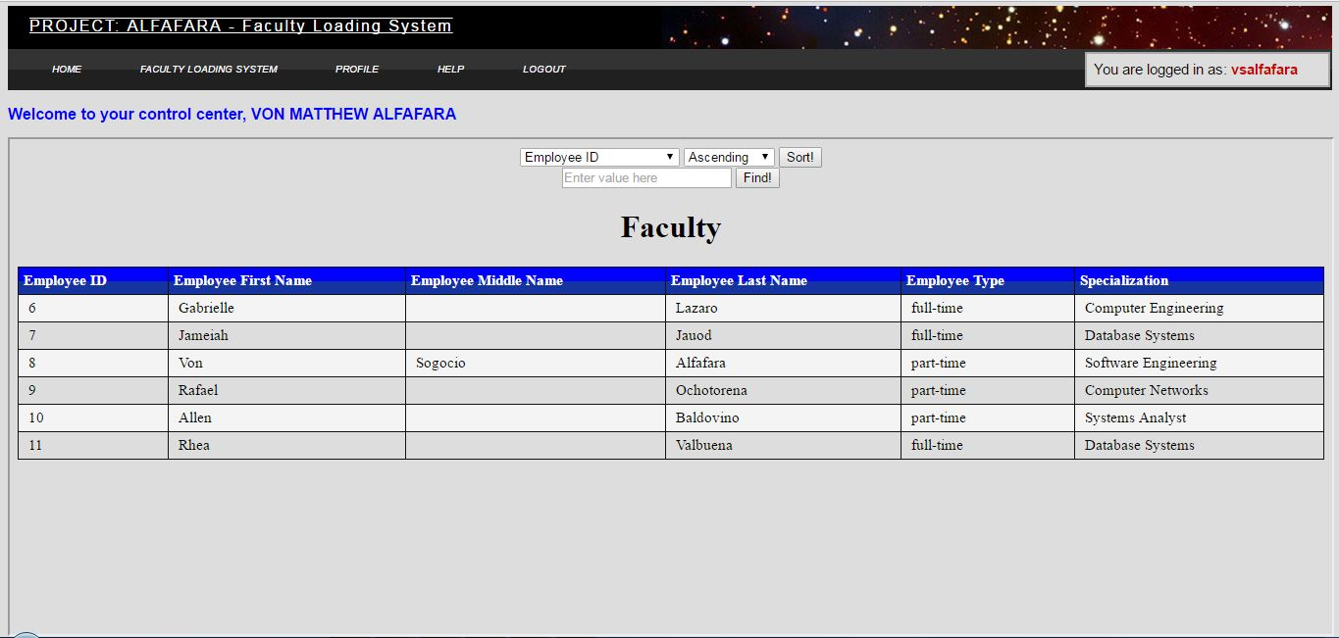

To which he/she would be able to load the schedules of faculty members.

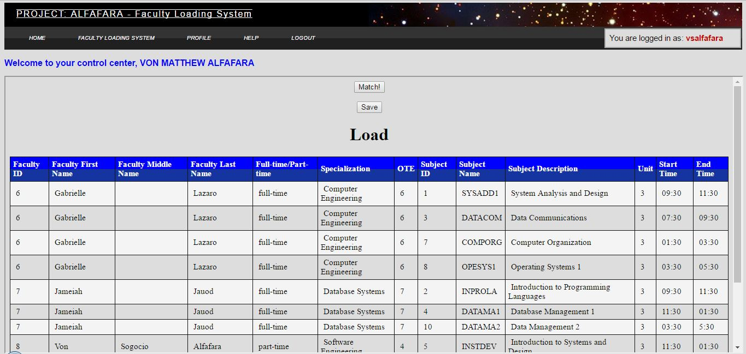

## Hardware Interfaces

The hardware components used for the product is a dual core 2.4 GHz+ processor, an 8GB RAM.

## Software Interfaces

The product was created through a cross-platform source code editor specifically notepad++ and Sublime Text, a cross-platform web server XAMPP, MySQL for the database, HTML, CSS and PHP, and all possible web browsers that a user may use.

## Communications Interfaces

The product is most likely be used by the school, Office365 would be used in means of communication. Google Chrome, Mozilla Firefox, and Microsoft Edge are the most used browsers nowadays to which it might be used by the users of the product. Since the product is integrated to the Flavio System, it could only be accessed within school territory because intranet is used.

# System Features

<This template illustrates organizing the functional requirements for the product by system features, the major services provided by the product. You may prefer to organize this section by use case, mode of operation, user class, object class, functional hierarchy, or combinations of these, whatever makes the most logical sense for your product.>

## Faculty Loading

4.1.1 Description and Priority

This feature is the main priority of the product by which this is what the product do. Algorithm is used to decide the matching of schedules for each faculty to the subjects they would have to teach. The product is used to ensure efficiency and effectivity for the user but errors may occur.

4.1.2 Stimulus/Response Sequences

The user must first review the necessary data needed for loading. Once finished, the user will tag which faculty will be teaching the next term then the system will use an algorithm to load the schedules of faculty.

4.1.3 Functional Requirement(s)

Criteria – these data are required in the system in order to generate faculty loading

Algorithm – this is the most important requirement of the system since it is responsible for matching the faculty schedules.

## Viewing of Schedules

4.2.1 Description and Priority

Faculty may view their respective schedules in order for them to review so they may request revisions when needed. This is medium priority since the faculty has the decision whether to view their schedules or not but is still necessary because revisions may be needed and the Executive Director must receive the request for revisions to prevent conflicts.

4.2.2 Stimulus/Response Sequences

When loading of schedules are finished, the data will immediately be sent to the account of the faculty in order for them to view. The faculty may then view the schedules and review it for revisions.

## Statistic Report

4.3.1 Description and Priority

One thing that makes this product unique is because of its statistical report which it will provide to the admin for analysis on the outcome it has given. This has a low priority but is in fact a big part of the product because the admin may be able to see how the criteria was weighted down for the faculty to end up on their specified schedules.

4.3.2 Stimulus/Response Sequences

After the system has loaded all the schedules of faculty, it will then generate a statistical report based on the criteria it has used such as: availability, history of teachings, specialization, online teaching evaluation data, rules and special cases. The admin may then review the report for necessary revisions.

4.3.3 Functional Requirement(s)

Power BI - is used for the system since it is known for its graphical presentations on data and statistics.

# Other Nonfunctional Requirements

## Performance Requirements

<If there are performance requirements for the product under various circumstances, state them here and explain their rationale, to help the developers understand the intent and make suitable design choices. Specify the timing relationships for real time systems. Make such requirements as specific as possible. You may need to state performance requirements for individual functional requirements or features.>

The product should be able to provide the admin

## Safety Requirements

All data should be complete before loading in order to prevent repetitive loading that would waste time, it will just negate the whole product’s goals and objectives. The data provided must also be precise and has no missing parts and incorrect information. This product highly gives importance to its criteria which is the reason why data has to be complete and precise.

## Security Requirements

This product is highly for Asia Pacific College School of Computing and Information Technology use only, all the information are kept in the Flavio System. Only the Executive Director is able to use load the system but the Faculty may be able to view their schedules. The system will also be accessible within APC territory since the school and the Flavio System uses intranet.

## Software Quality Attributes

<Specify any additional quality characteristics for the product that will be important to either the customers or the developers. Some to consider are: adaptability, availability, correctness, flexibility, interoperability, maintainability, portability, reliability, reusability, robustness, testability, and usability. Write these to be specific, quantitative, and verifiable when possible. At the least, clarify the relative preferences for various attributes, such as ease of use over ease of learning.>

## Business Rules

The following are the roles for each involved including the system itself.

* The Executive Director will use the system to load the schedule of faculty.
* Faculty may view their schedules in order to request for revisions and reschedules.
* The system will generate a statistic report on loading the schedules.
* The Executive Director must update the teaching assignment database.

# Other Requirements

<Define any other requirements not covered elsewhere in the SRS. This might include database requirements, internationalization requirements, legal requirements, reuse objectives for the project, and so on. Add any new sections that are pertinent to the project.>

# Appendix A: Glossary

<Define all the terms necessary to properly interpret the SRS, including acronyms and abbreviations. You may wish to build a separate glossary that spans multiple projects or the entire

organization, and just include terms specific to a single project in each SRS.>

# Appendix B: Analysis Models

<Optionally, include any pertinent analysis models, such as data flow diagrams, class diagrams, state-transition diagrams, or entity-relationship diagrams.>

# Appendix C: To Be Determined List

<Collect a numbered list of the TBD (to be determined) references that remain in the SRS so they can be tracked to closure.>